Assignment-7 EEC-3150 Engineering Programming II
- In the Blackboard Resources is a LinkedIn Learning course entitled Python Essential Training.

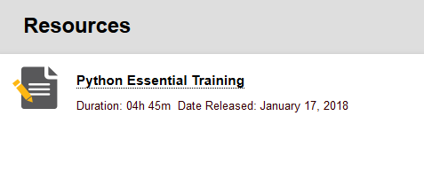
Review any lessons from the following chapters to increase your understanding:
Chapter 11 String Objects

You may choose any of the videos, or all of the videos that will increase your knowledge of the Python programming language. You are to enumerate three learnings from the videos you have selected. Each of the three learnings should be described in one or two sentences.

- Write the function subStringMatch. This function takes two arguments: a target string, and a key string. It should return a tuple of the starting points of matches of the key string in the target string, when indexing starts at 0. The funtion arguments can be any string. The "matching" algorithm is case insensitive. Therefore, 'a' is a match to 'A'. Be sure to account for all types of function arguments, including non-string arguments and the string of length zero. You MUST have at least one try/exception in the function. Document the function, including docstring, and test it thoroughly.

Example:

subStringMatch("atgacatgcacaagtAtgcat","atgC") would return the tuple (5, 15).

In addition, your script/program should have an informative header and comments throughout.
Submit: A file called Assignment-7-Results.docx to Blackboard.

